|  |  |  |  |  |  |
| --- | --- | --- | --- | --- | --- |
| Name: | | \_\_\_\_\_\_\_\_\_\_\_\_\_\_\_\_\_\_\_\_\_\_\_\_\_\_\_\_\_\_\_ | | | Date: *\_\_\_\_\_\_\_\_\_\_\_* |
| S:\AdminShared\All Staff\1 College Logo's\Baldivis_Logo_colour.jpg | | **Year 11 Mathematics: Applications**  **Investigation 4, 2016**  **Topic – Linear Equations and their graphs**  **Take-Home Component** | | | |
| **Important Information:**  *Although the take-home component is not worth any marks, it is essential in preparation for the in-class component. Knowledge and skills gained will be extended in the in-class validation component. This in-class validation will be completed under test conditions on the day in which this take-home component is due. The take-home component may be used when completing the in-class component. Contact may be made to parent(s) if the take-home component is not available for submission (at the start of the lesson).* | | | | | |
| **Date out:** | *Week \_\_\_\_ Date \_\_\_\_\_\_\_\_\_\_\_\_* | | **Date Due:** | *Week \_\_\_\_ Date \_\_\_\_\_\_\_\_\_\_\_\_* | |
| **Take home component weighting:** | *0% of the year* | | **In-class component weighting:** | *10% of the Semester, 5% of the Year* | |
| **AIM:** *In this assessment, you will be investigating linear equations and their graphs.* | | | | | |

**Question 1**

The table below shows the schedule for parking fees at a local hospital.

The car park is open from 6:00 am to 6:00 pm

Draw a step graph to represent the data.

**Parking fees**

|  |  |  |
| --- | --- | --- |
| Time (hours) | | Cost |
| Equal to or more than | Less than |  |
| 0 | 0.5 | $9 |
| 0.5 | 1 | $11 |
| 1 | 1.5 | $15 |
| 1.5 | 2 | $18 |
| 2 | 2.5 | $20 |
| 2.5 | 3 | $23 |
| 3 | 3.5 | $26 |
| 3.5 | 4 | $29 |
| 4 | 8 | $31 |
| 8 | 12 | $33 |

**Question 2**

In the 2014 Commonwealth games, the triathlon consisted of three stages: a 1500 m swim followed by a 40 km bike ride and then a 10 km run for both the men’s and the women’s events. The winners completed the three stages in the times below.

Swim Cycle Run

Men’s event 18 mins 58 mins 43 secs 31 mins 9 secs

Women’s event 19 mins 37 secs 1 h 4 mins 1 sec 34 mins 21 secs

(a) Convert all times to minutes correct to one decimal place.

(b) Calculate the average speed (km/h) of the winners on each stage of the triathlon.

(c) On the same set of axes, draw two piece-wise graphs – one for the men’s event and the other for the women’s event - showing the distance covered for the time taken.

Plot “time taken” (in minutes) on the horizontal axis and “distance covered” on the vertical axis.

(d) Compare the performance of the two triathletes.

(e) What conclusions can you draw about each winner’s performance on the different stages of the triathlon?

**Question 3**

The graphs below show the cost of posting parcels to locations overseas in 2014. The first graph is for transport by air and the second is for sea transport.

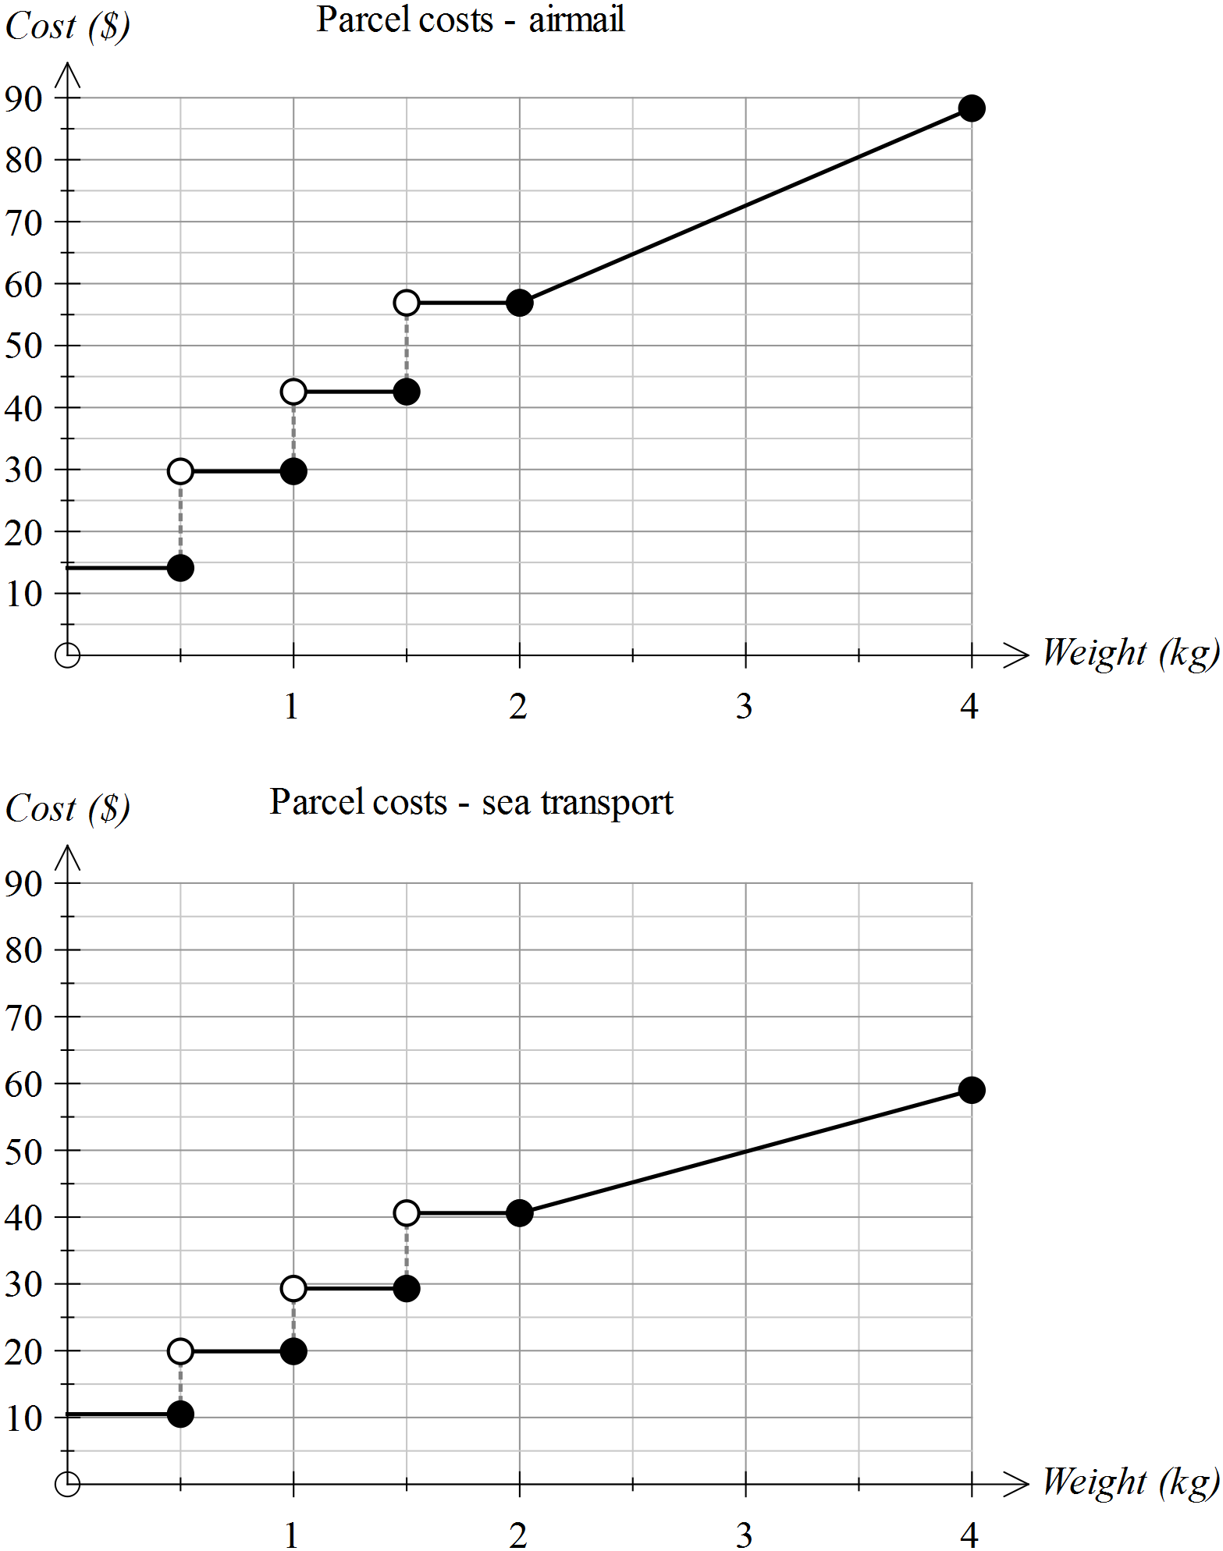

(a) Use the graphs to determine the approximate costs for sending these parcels.

(i) A parcel weighing 500 g by air and by sea

(ii) A parcel weighing 1.8 kg by air

(iii) A parcel weighing 1.99 kg by air

(iv) A parcel weighing 3 kg by sea

(v) A parcel weighing 4 kg by air

(b) Using a different colour, place the data from the second graph onto the first graph. Describe the location of the new graph in relation to the original one.

(c) Consider the following statement.

*For the same weight, it is always cheaper to send the parcel by sea than by air*

Is this statement always true? How would you know this from the graphs?

(d) There is a change to pricing when the parcel is over 2 kg.

*A. The price is set for a fixed range of weights*

*B. The price increases by a fixed amount per kg*

Which of the two statements above applies when the parcel is

(i) under 2 kg in weight

(ii) over 2 kg in weight

(e) What is the approximate cost per kg of sending a parcel overseas by air if the parcel weighs more than 2 kg?

(f) Determine the rate at which the cost changes per kg, when a parcel to be sent overseas by sea, weighs more than 2 kg.

(g) Determine the gradients of the following lines - the lines linking the costs of postage for parcels

(i) sent overseas by air and weighing less than 500 g

(ii) sent overseas by air and weighing over 2 kg

(iii) sent overseas by sea and weighing over 2 kg

(iv) sent overseas by sea and weighing between 1.5 kg and 2 kg

(h) Consider the following change to the cost of sending a parcel overseas by sea transport.

*The price will rise by $5 within each range of weights between 0 and 2 kg.*

*The cost per kg for parcels weighing more than 2 kg will remain unchanged.*

Add a new graph to the second graph to reflect this change.

**Question 4**

The cost of postage for parcels less than 2 kg in weight is displayed as a step graph. Locate at least five other examples of data for which a step graph would be most appropriate.

**Question 5**

Jon pays his water bill every two months. It consists of a fixed charge for the connection and sewage plus a fee that varies according to the amount of water used. The graph of the pricing schedule is shown below.

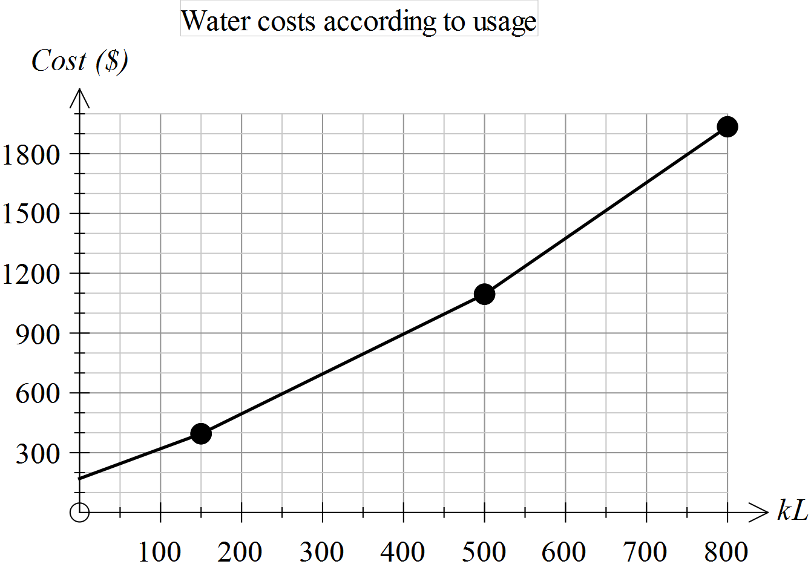

(a) Estimate the total fixed charge.

(b) At what levels of water usage do the rates at which water is charged vary?

(c) Is it true to say that “when the rates vary, they are increasing”? How can you verify your conclusion from the graph provided?

(d) Determine the approximate charges for the following water usages.

(i) 100 kL (ii) 0.25 ML

(iii) 650 kL (iv) 50 000 L

(e) Use the graph to determine the rate at which water is charged when the consumption is over 500 kL.

(f) Explain how you can determine the equation of the first section of this piece-wise graph.

(g) The second section of this piece-wise graph has the equation

*Cost = 2* x *Number of kL + 95*

What is the significance of “2” in the equation above?

|  |  |  |  |  |  |  |
| --- | --- | --- | --- | --- | --- | --- |
| Name: | \_\_\_\_\_\_\_\_\_\_\_\_\_\_\_\_\_\_\_\_\_\_\_\_\_\_\_\_\_\_\_\_\_\_\_\_\_\_\_\_ | | | | | Date: *\_\_\_\_\_\_\_\_\_\_\_* |
| Description: S:\AdminShared\All Staff\1 College Logo's\Baldivis_Logo_colour.jpg | **Year 11 Mathematics: Applications**  **Investigation 4, 2016**  **Topic – Linear equations and their graphs**  **In Class Component** | | | | | 50  = % |
| **Total Time:** | ***55*** *minutes* | |  | | | |
| **Reading Time:** | *5**minutes* | |
| **Working Time:** | *50**minutes* | |
| **Equipment:** | *SCSA Formula sheets, ClassPad, scientific calculator, take-home component* | | | | | |
| **Date out:** | | *Week \_\_\_\_ Date \_\_\_\_\_\_\_\_\_\_\_\_* | | **Date Due:** | *Week \_\_\_\_ Date \_\_\_\_\_\_\_\_\_\_\_\_* | |
| **Take home component weighting:** | | *0% of the year* | | **In-class component weighting:** | *10% of semester, 5% of the year* | |
| **AIM:** *In this assessment, you will be investigating linear equations and their graphs.* | | | | | | |

**Question 1 (6 marks)**

Ida parks her car at 8.00 am at the university where parking costs $1.50 per hour. She leaves there at 10 am and arrives at the airport at 10:45 am where she parks the car for an hour at $4 per hour. She then drives to the city, arriving at 12.15 pm and parks on the Esplanade at a cost of $4.50 per hour for 2 hours. She then leaves the city and drives home, arriving there at 3.00 pm.

Use the axes below to graph the amount Ida pays for parking from 8.00 amto 3.00 pm**.**

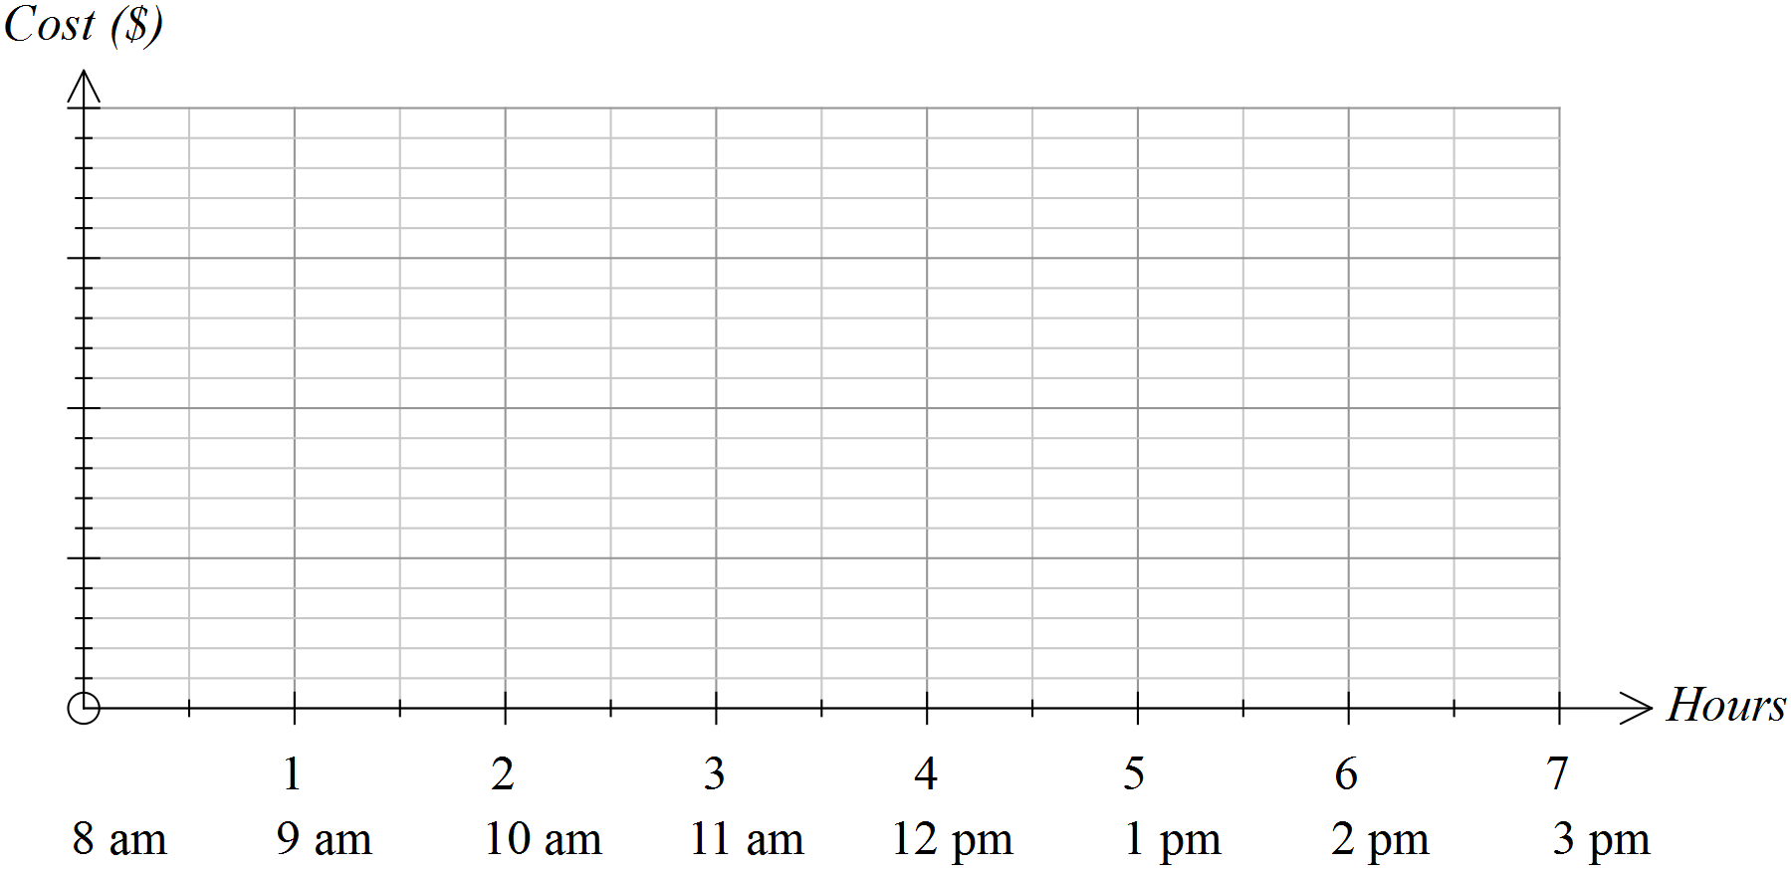

**Question 2 (7 marks)**

The cost of parking at the airport for up to 5 hours is summarised in the table. Show these costs on the axes provided.

|  |  |  |  |  |
| --- | --- | --- | --- | --- |
| First 15 mins | Over 15 mins  Up to 30 mins | Over 30 mins  Up to 1 hour | Over 1 hour  Up to 2 hours | After 2 hours it is an extra $2 per hour or part thereof |
| Free | $5 | $8 | $12 |  |

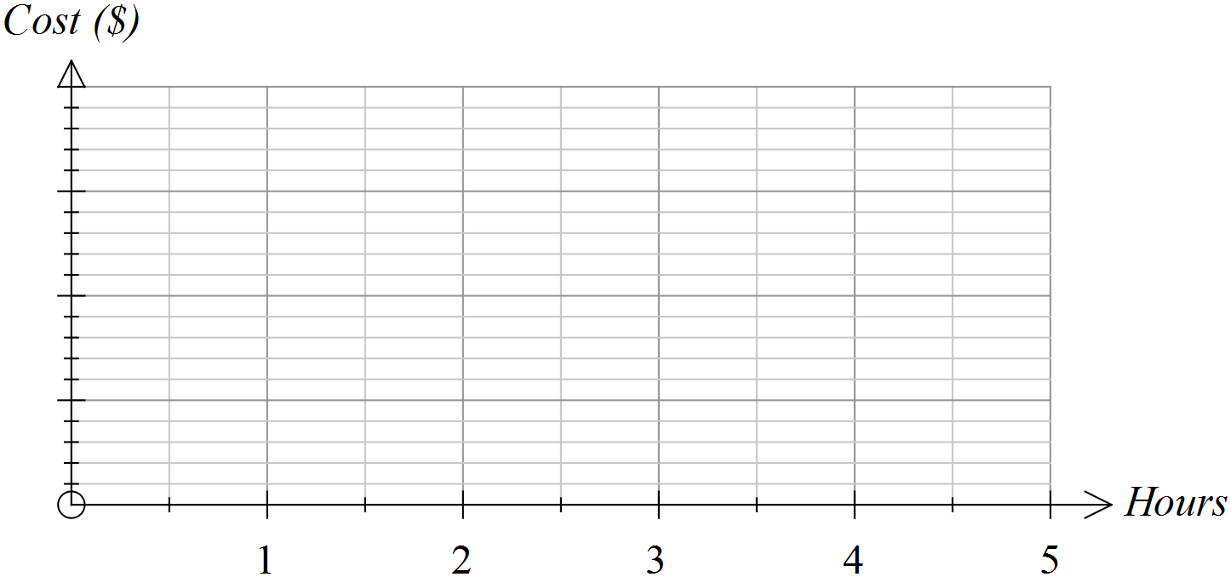

**Question 3 (10 marks)**

The costs of sending parcels of varying weights by post are represented in the graph below.

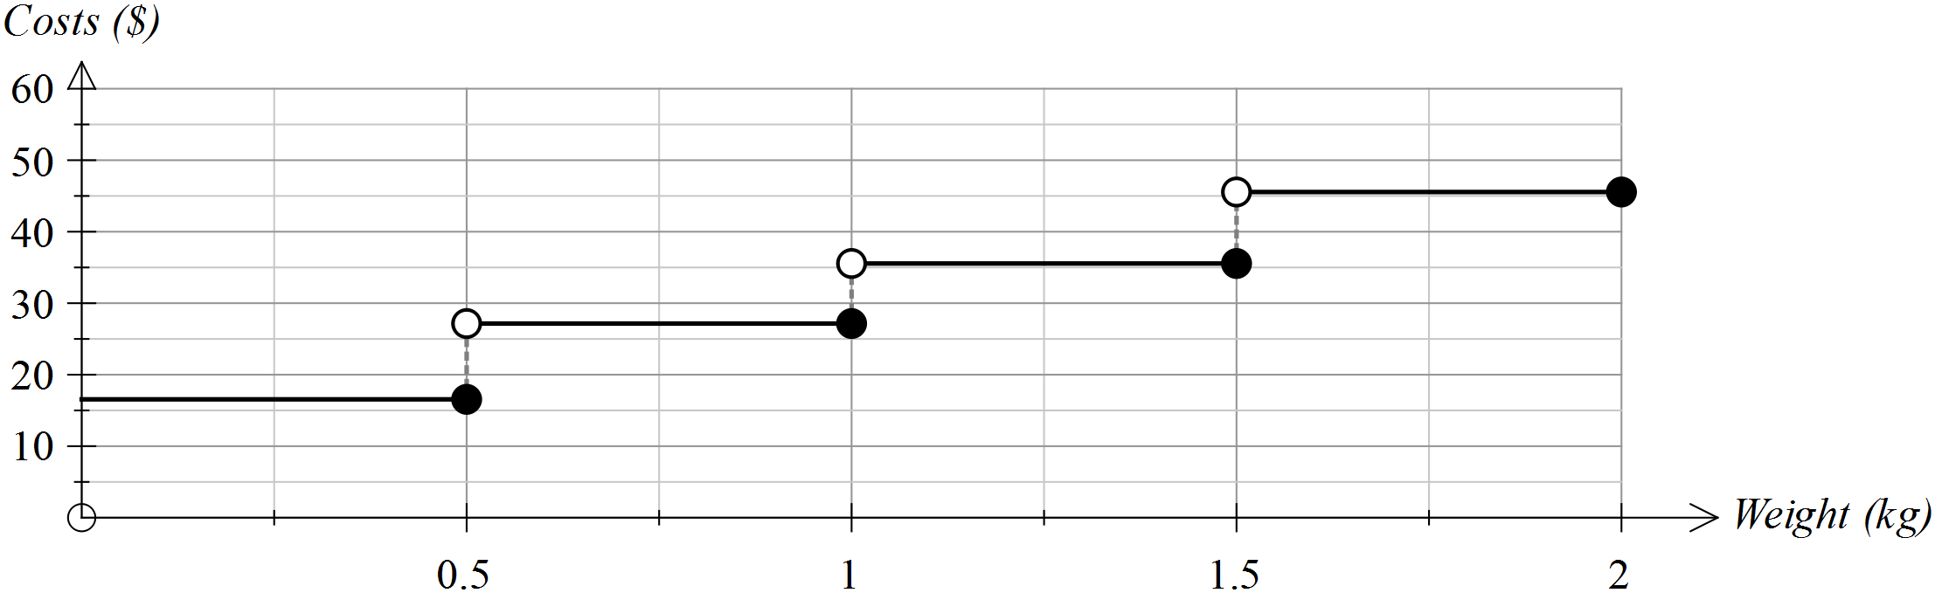

Use the graph to answer the following questions.

(a) What is the approximate cost of sending a parcel weighing 500 g? (1)

(b) What is the approximate cost of sending a parcel weighing 120 g? (1)

(c) If you had $40 to spend on the postage of one parcel, what is the maximum weight that the parcel could be? (1)

(d) If you were told that your parcel would probably cost less than $30, what might its weight be? (2)

(e) A decision was made to lower the costs by $10 in each weight range.

Draw the graph showing these lowered costs on the graph drawn above. (2)

(f) A decision was made to lower the costs by 50% in each weight range.

Draw the graph showing these lowered costs on the graph drawn below. (3)



**Question 4 (10 marks)**

Tom and Mary were driving in a car rally last week. The time taken to return to their starting point is shown in the graph below.

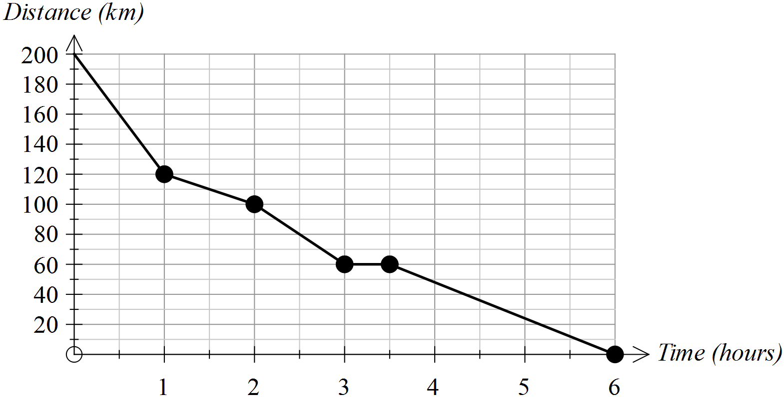

(a) How far was the return journey? (1)

(b) How long did the return journey take? (1)

(c) During which hour did Tom and Mary average the highest speed? (2)

How did you determine this answer from the graph?

(d) For how long did Tom and Mary stop? (2)

(e) At what average speed were Tom and Mary travelling during the last hour of their journey? Show how you determined your answer. (2)

(f) Tom and Mary started their return journey at 6.00 am. (2)

(i) How far had they travelled by 8.30 am?

(ii) Add a segment to this graph to indicate that Tom and Mary could have travelled at a constant speed between 9.00 am and 11.00 am.

**Question 5 (17 marks)**

The cost of travelling on a city train varies according to the number of zones travelled.

The table provided shows the;

* stations numbered 1 to 9
* distance to each station from the city
* cost of travelling to that station from the city
* time taken to reach each station from the city.

|  |  |  |  |  |  |  |
| --- | --- | --- | --- | --- | --- | --- |
| Station | Distance from city (km) | Cost  from the city | Time taken from city  (mins) | Time taken since last station  (mins) | Distance since last station  (km) | Cost since the last station |
| 1 | 7.3 | $2.90 | 6 | 6 | 7.3 |  |
| 2 | 11.7 | $4.40 | 9 | 3 | 4.4 |  |
| 3 | 13.8 | $4.40 | 11 |  | 2.1 |  |
| 4 | 20.5 | $5.30 | 16 |  | 6.7 |  |
| 5 | 32.9 | $6.30 | 23 |  | 12.4 |  |
| 6 | 37.39 | $6.30 | 29 |  | 4.49 |  |
| 7 | 43.2 | $7.80 | 33 |  | 5.81 |  |
| 8 | 47.6 | $7.80 | 36 |  | 4.4 |  |
| 9 | 70.19 | $10.30 | 48 |  | 22.59 | $2.50 |

(a) Complete the table. (4)

(b) The graph below shows the cost of travel according to the distance travelled. (8)

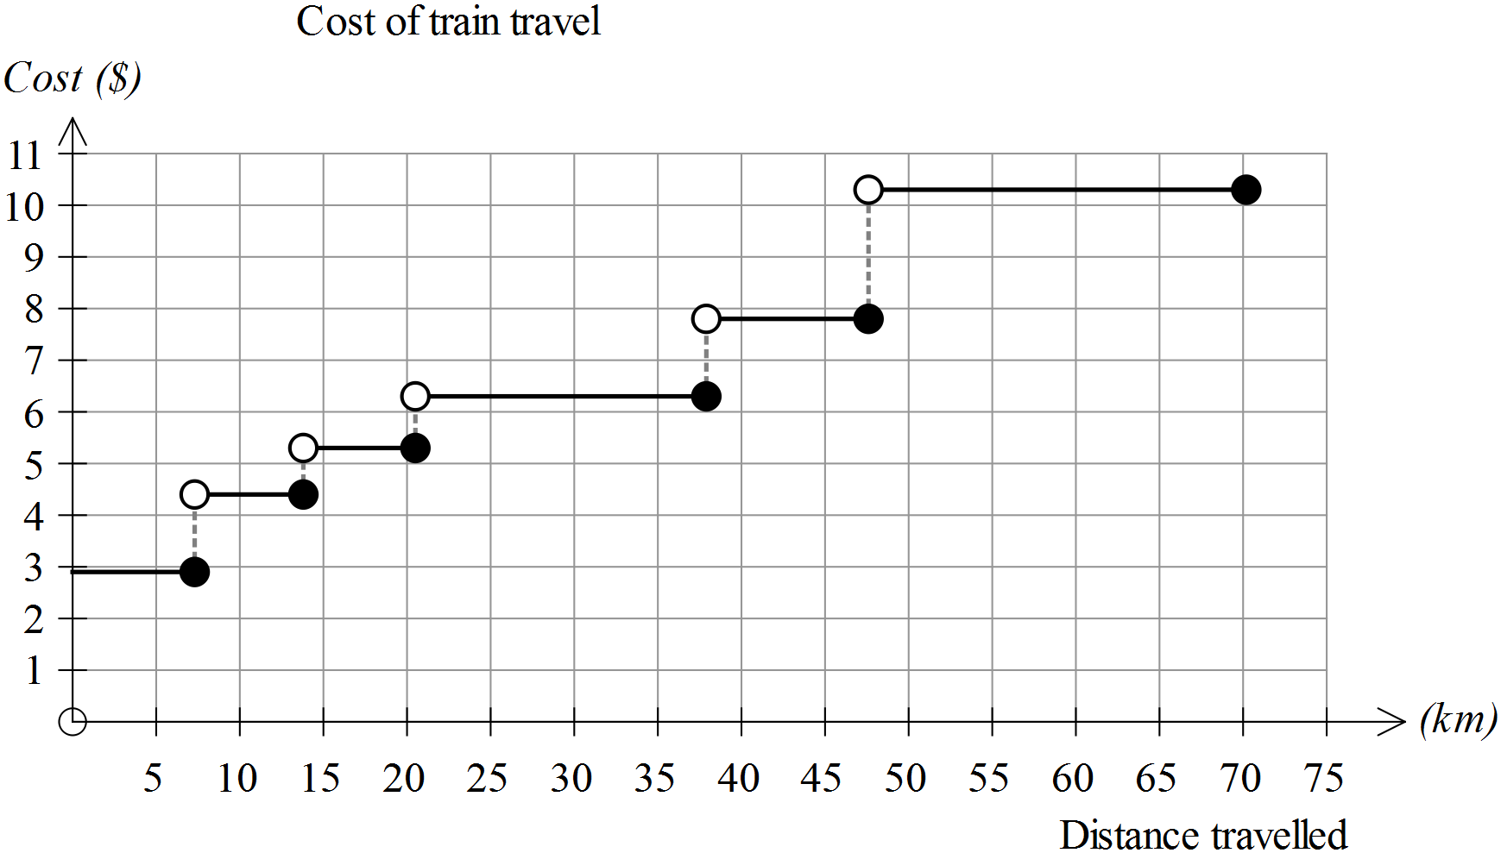

(i) How many different prices are used for this schedule of costs? (1)

(ii) At which distance from the city does the sharpest rise in costs occur? (1)

(iii) What would you need to do to this graph to show an increase of $1 on all the fares given in the table? (2)

(iv) For people who receive a 15% discount on their fares, how would their graph of costs be different to the one above? (2)

(v) It was suggested that, rather than increase the fares the same fares would apply, but the stations would be moved so that they were closer to the city. How would the new graph of costs differ from the one given? (2)

(c) If you plotted time on the horizontal axis and distance travelled on the vertical axis, would you create a step graph or a piece-wise linear graph? Justify your conclusion. (2)

(d) Is the following statement True or False? Justify your conclusion. (3)

*The further you travel from the city, the less it costs per kilometre.*

**End of questions**

**Linear with a difference**

**Extended investigation Part 1:** **Preparation activity**

**Solutions**

**Question 1**

|  |
| --- |
|  |

**Question 2**

|  |  |  |  |  |  |  |  |  |  |  |  |  |  |  |  |  |  |  |  |  |  |  |  |  |
| --- | --- | --- | --- | --- | --- | --- | --- | --- | --- | --- | --- | --- | --- | --- | --- | --- | --- | --- | --- | --- | --- | --- | --- | --- |
| (a) Swim Cycle Run  Men’s event 18 mins 58.7 mins 31.2 mins  Women’s event 19.6 mins 64.0 mins 34.4 mins  (b) Swim Cycle Run  Men’s event 5 km/h 40.9 km/h 19.2 km/h  Women’s event 4.6 km/h 37.5 km/h 17.4 km/h    (c) Table of data for graph. Graph drawn on the next page.   |  |  |  |  | | --- | --- | --- | --- | | Triathlon | Time elapsed (to nearest minute) | | Distance | |  | Men's | Women's | km | | Start | 0 | 0 | 0 | | After swim | 18 | 20 | 1.5 | | After cycle | 77 | 84 | 41.5 | | End | 108 | 118 | 51.5 |   (d) For each stage of the triathlon, the female winner was slower than the male.  (e) For both triathletes, the fastest stage was the cycle leg and the slowest was the swimming leg. Both athletes ran about four times as fast as they swam and cycled about twice as fast as they ran. |

**Question 2 (c)**

|  |
| --- |
|  |

**Question 3**

|  |
| --- |
| (a) (i) About $15 by air and $10 by sea (ii) $57 (iii) $57  (iv) $50 (v) $90  (b) See graphs below  The graph for transport by sea is located directly underneath the first graph until the price reaches 2 kg. After 2 kg, the graph is lower but the line is not as steep for transport by sea.  (c) True  For the same values (weight range) along the horizontal axis, the values for the cost of transport by sea are lower than (below) those for transport by air on the vertical axis.  (d) (i) A (ii) B  (e) 73-57 = $16 per kg  (f) 60-50 = $10 per kg  (g) (i) 0 (ii) 16 (iii) 10 (iv) 0  (h) See addition to second graph below |

**Question 3 (cont’d)**

(c), (h)

|  |
| --- |
|  |

**Question 4**

|  |
| --- |
| Other data for which step graphs are suitable include   * Cost of posting parcels interstate * Parking fees in city car parks * Costs of travelling on public transport * Costs of medical consultations * Interest rates on long term deposits |

**Question 5**

|  |
| --- |
| (a) $180  (b) at 150 kL and 500 kL  (c) Yes. As the number of kL increases, the gradient of the line segment increases because the line segments are increasingly steeper.  (d) (i) $310 (ii) $600 (iii) $1500 (iv) $250  (e)    Rate = 800 ÷ 300 = $2.7 per kL  (f) Vertical intercept = $180, gradient = (400-180) ÷ 150 ~ 1.5  Cost = $1.5 x Number of kL + $180  (g) The cost per kL ~ $2 which is the gradient of the line in that section of the graph. |

**Linear with a difference**

**Extended investigation Part 2:** **In-class validation**

**Solutions**

**Question 1**

|  |
| --- |
| Solution |

|  |  |
| --- | --- |
| Marking key/mathematical behaviours | Marks |
| * Scales vertical axis * Represents parking for 2 hours at $1.50 per hour * Shows zero gradient for no change in costs (including to 3 pm) * Draws rise of $4 for 1 hour * Draws rise of $4.50 for 2 hours | 1  1  2  1  1 |

**Question 2**

|  |
| --- |
| Solution |

|  |  |
| --- | --- |
| Marking key/mathematical behaviours | Marks |
| * Scales vertical axis * Shows the correct costs up to 2 hours * Costs are matched to correct time periods * Open and closed circles used correctly * Increases hourly cost by 2 from 2-5 hours | 1  2  1  2  1 |

**Question 3**

|  |  |  |  |
| --- | --- | --- | --- |
|  | Solution | Marking key/mathematical behaviours | Marks |
| (a) | $16 | * Reads graph correctly | 1 |
| (b) | $16 | * Reads graph correctly | 1 |
| (c) | 1.5 kg | * Interprets graph correctly | 1 |
| (d) | Any weight up to and including 1 Kg | * Reads values from 0.5 to 1 kg * Includes values from 0 to 0.5 kg | 1  1 |
| (e) | See below | * Moves each line down 10 $ * Keeps weight ranges correct | 1  1 |
| (f) | See below | * Moves each line down 50% in all ranges * Keeps weight ranges correct | 2  1 |
| (e)  (f) | | | |

**Question 4**

|  |  |  |  |
| --- | --- | --- | --- |
|  | Solution | Marking key/mathematical behaviours | Marks |
| (a) | 200 km | * Interprets vertical intercept | 1 |
| (b) | 6 hours | * Interprets horizontal intercept | 1 |
| (c) | First hour  Steepest line segment | * Identifies highest speed * Links speed to gradient | 1  1 |
| (d) | 0.5 hours | * Interprets zero gradient - reads time * Correct units | 1  1 |
| (e) | 24 km/h  60 km ÷ 2.5 h = 24 km/h | * Determines speed * Provides evidence of determination | 1  1 |
| (f) | 120 km  Draws line (3,60) to (5, 22) | * Calculates distance * Draws straight line | 1  1 |

**Question 5**

|  |  |  |  |  |  |  |  |
| --- | --- | --- | --- | --- | --- | --- | --- |
| Station | Distance from city (km) | Cost  from the city | Time taken from city  (mins) | Time taken since last station  (mins) | Distance since last station  (km) | Cost since the last station | Cost /Km |
| 1 | 7.3 | $2.90 | 6 | 6 | 7.3 | $2.90 | $0.40 |
| 2 | 11.7 | $4.40 | 9 | 3 | 4.4 | $1.50 | $0.38 |
| 3 | 13.8 | $4.40 | 11 | 2 | 2.1 | 0 | $0.32 |
| 4 | 20.5 | $5.30 | 16 | 5 | 6.7 | $0.90 | $0.26 |
| 5 | 32.9 | $6.30 | 23 | 7 | 12.4 | $1.00 | $0.19 |
| 6 | 37.39 | $6.30 | 29 | 6 | 4.49 | 0 | $0.17 |
| 7 | 43.2 | $7.80 | 33 | 4 | 5.81 | $1.50 | $0.18 |
| 8 | 47.6 | $7.80 | 36 | 3 | 4.4 | 0 | $0.16 |
| 9 | 70.19 | $10.30 | 48 | 12 | 22.59 | $2.50 | $0.15 |

|  |  |  |  |
| --- | --- | --- | --- |
|  | Solution | Marking key/mathematical behaviours | Marks |
| (a) | See table | * Calculates differences in time * Calculates differences in cost | 2  2 |
| (b) | (i) 6  (ii) 47.5 km  (iii) Move all lines with open and closed circles up by 1 unit  (iv) Graph lines would be lowered by increasing amounts  (v) The lines would shrink horizontally and circles would move left. | * Interprets horizontal values * Reads differences in vertical values * Identifies vertical translation up 1 unit * Identifies downwards movement * Indicates amount of movement varies * Interprets horizontal changes * Indicates vertical values remain | 1  1  2  1  1  1  1 |
| (c) | Piece-wise linear  The gradient is constant but not 0 between time periods | * Identifies correct type of graphs * Indicates understanding of variation in gradients | 1  1 |
| (d) | Generally true  Shows decreasing costs – see table above | * Concludes correctly * Provides evidence to support conclusion * Provides several pieces of evidence to support conclusions | 1  1  1 |